ANALYSING OF EXISTING SOLUTIONS

Reviewing existing digital solutions in the green sector industry would help me identify best practices in user experience, carbon-tracking, energy monitoring and booking workflows which are all the requested requirements and features listed by Rolsa Technologies. This part of the document would also highlight the gaps, good practices and weaknesses to help prepare for our digital solution and features we can adopt in our solution especially around carbon footprint calculation, consultation and installation scheduling, product education all in one place.

The first solution I would be reviewing is **Octopus Energy**. They provide customer dashboards for energy usage, smart tariffs, account management and clear educational content around energy savings.

Some of the best practices I observed with the platform are they have a strong account-based journey were customers register, login and can manage everything assigned to them. Secondly, it has clear and simple usage visuals like easy-to-read graphs. Lastly, it had transparent communication of their services such as quotes, support and clarity of billings.

For the weakness of the platform, they mainly focused on energy supply rather than solar installations, maintenance scheduling. Furthermore, users typically cannot manage a full end-to-end install lifecycle from consultation to survey installing and to maintenance all in one workflow.

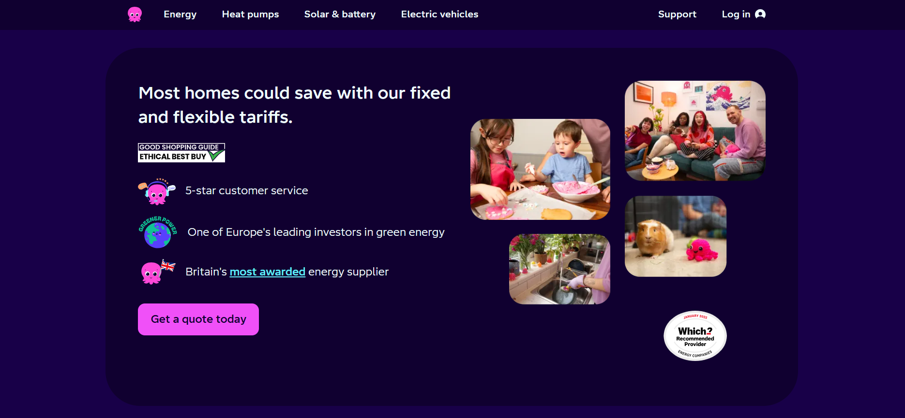

Some of the features I can borrow is their simple energy-usage dashboards and plain language tips

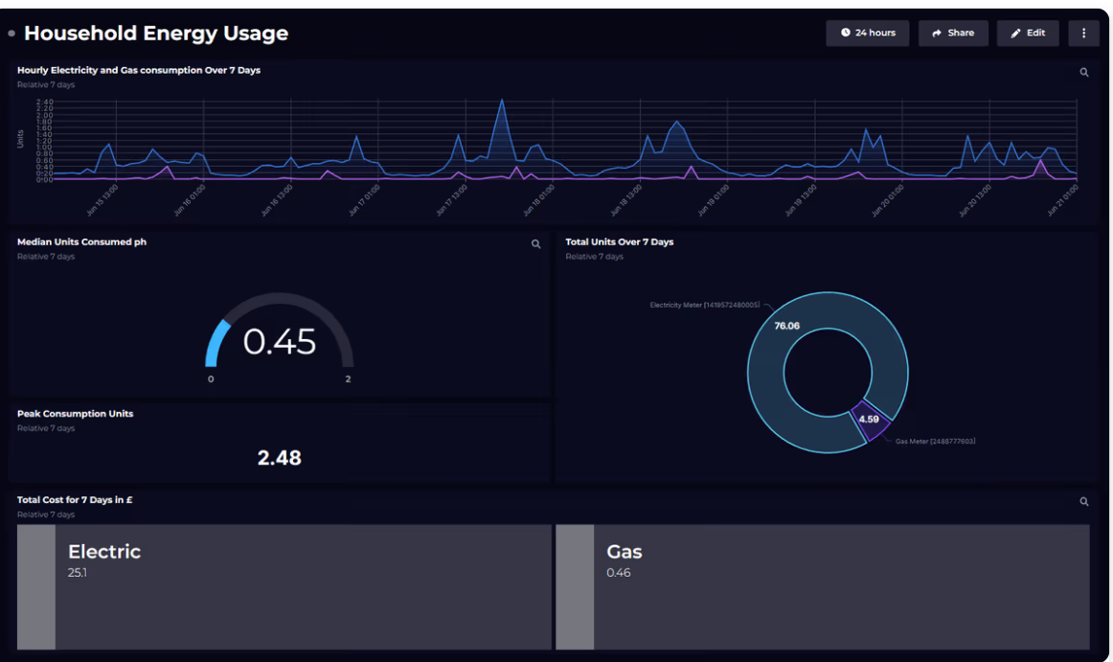

Then there is improving my digital solution by adding their installation lifecycle tracking from status updates to documents, to booking reschedules.

Secondly, looking at **Tesla Energy**, they provide solar and Powerwall monitoring all just through an app which shows the solar generation, battery charge and home usage.

For **Tesla Energy**, it has excellent real-time monitoring and tracking with clear and engaging visuals, it also makes progress visible which helps its users be encouraged to check the app/ website regularly. It has a high perceived reliability due to its strong branding as it is **TESLA**.

Its limitations were few, but some stood out to me. Firstly, its ecosystem can feel brand locked in the sense it only works best with TESLA hardware which might not cater to a wider audience. Also, it has a less an educational marketplace approach and focus is more on monitoring the product you already bought. Lastly, scheduling for support varies and it can make customers feel less flexible depending on their region.

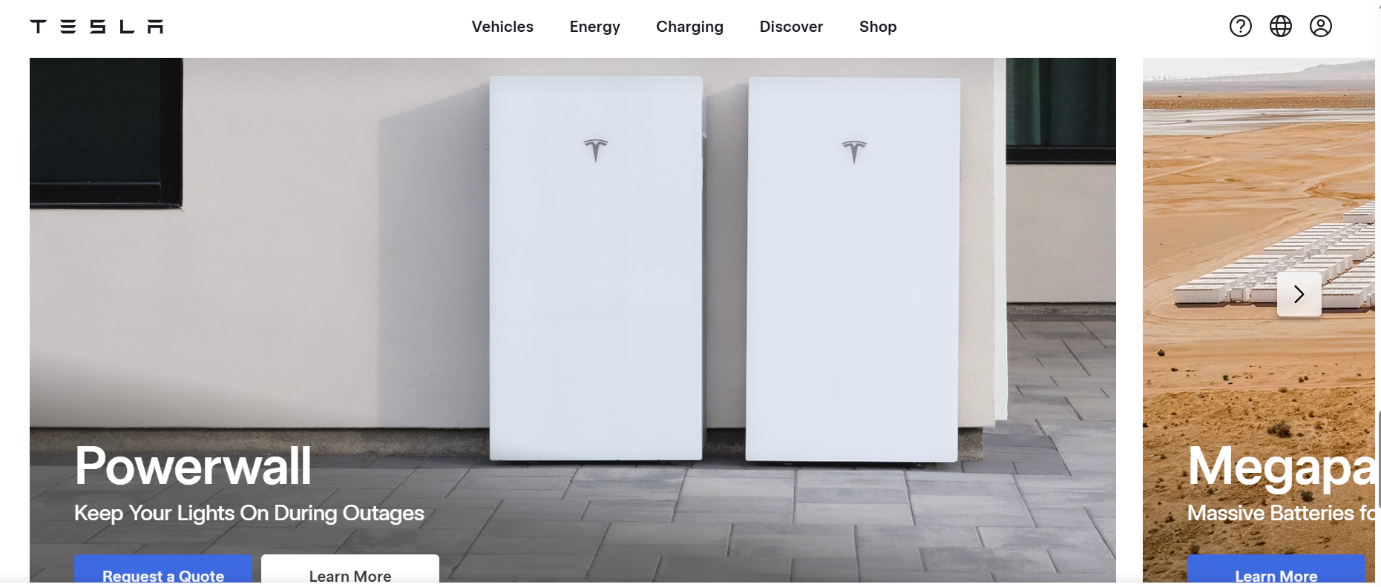

But there are some features and knowledge we can take from TESLA ENERGY’S platform/app which we can apply as we plan for our digital solution. I can adopt the real time monitoring dashboard concept for the tracking of energy usage requested by Rolsa Technology even if it's a later integration. Lastly, I can differentiate our digital solution by staying brand neutral so supporting multiple solar panel brands, EV chargers, and smart home systems.

Thirdly, I would be reviewing **SolarEdge and Enphase**. They provide solar monitoring platforms, often used by both installers and homeowners from generation of energy to system health to even alerts.

The strengths of the platform I observed where they had a good system-health visibility, so there would be alerts for faults, performance drops or any needs for maintenance. It also has a strong technical detail for installers giving them high level access to device-level insights.

Its weaknesses were; its interfaces can be too technical just for average homeowners like me. Also, they often split between installer tools and homeowner apps, so the whole ecosystem is not always unified. Lastly, it has limited education on carbon footprint” beyond their energy generation stats.

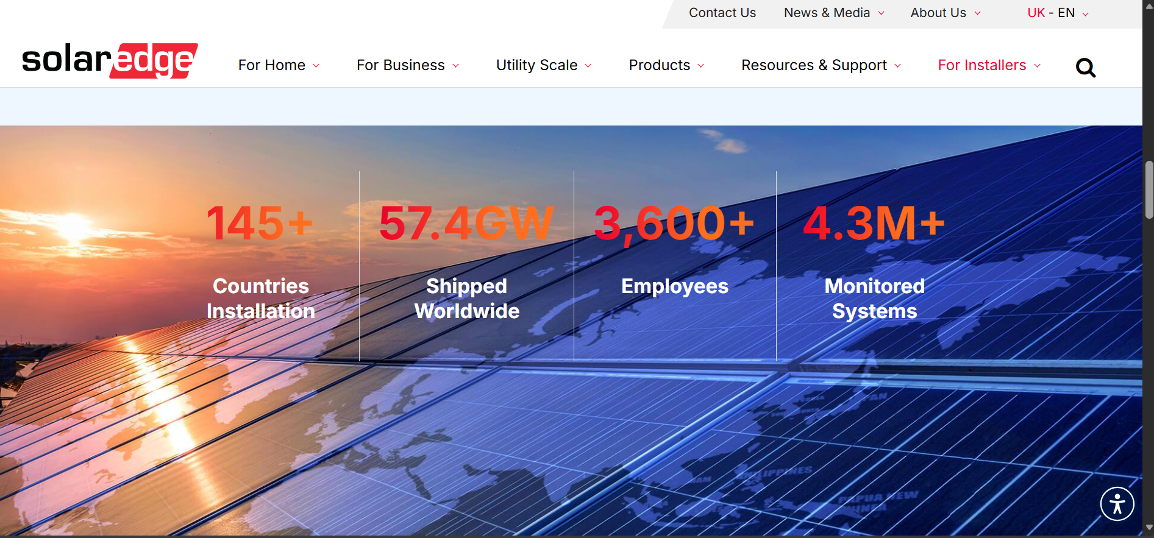

Some features whether tangible or not I can take from it is firstly its customer mode; Its simple and goal focused like its aim on savings, carbon reduction, and what to do next after your installation. Adapting this customer mode concept in the platform where users can see in their personalised dashboards “This month you saved x kg of C02, translating the technical data into human outcomes. It also has an admin/Installer mode where technical logs, appointment schedule, and customer history is shown which we can use to manage all the bookings for installations and consultations.

Fourthly, **Myenergi and Zappi**. These platforms provide EV charger control and some energy insights, which is usually tied to their charger ecosystem.

**Strengths**

It has a clear, practical EV-focused controls like charging scheduling and usage visibility. It also encourages greener behaviour thorough charging cheaper or greener if setup.

**Weaknesses**

It is often hardware tied and has limited comparisons across charger brands. It also has less focus on consultation bookings, education or even broader carbon footprint.

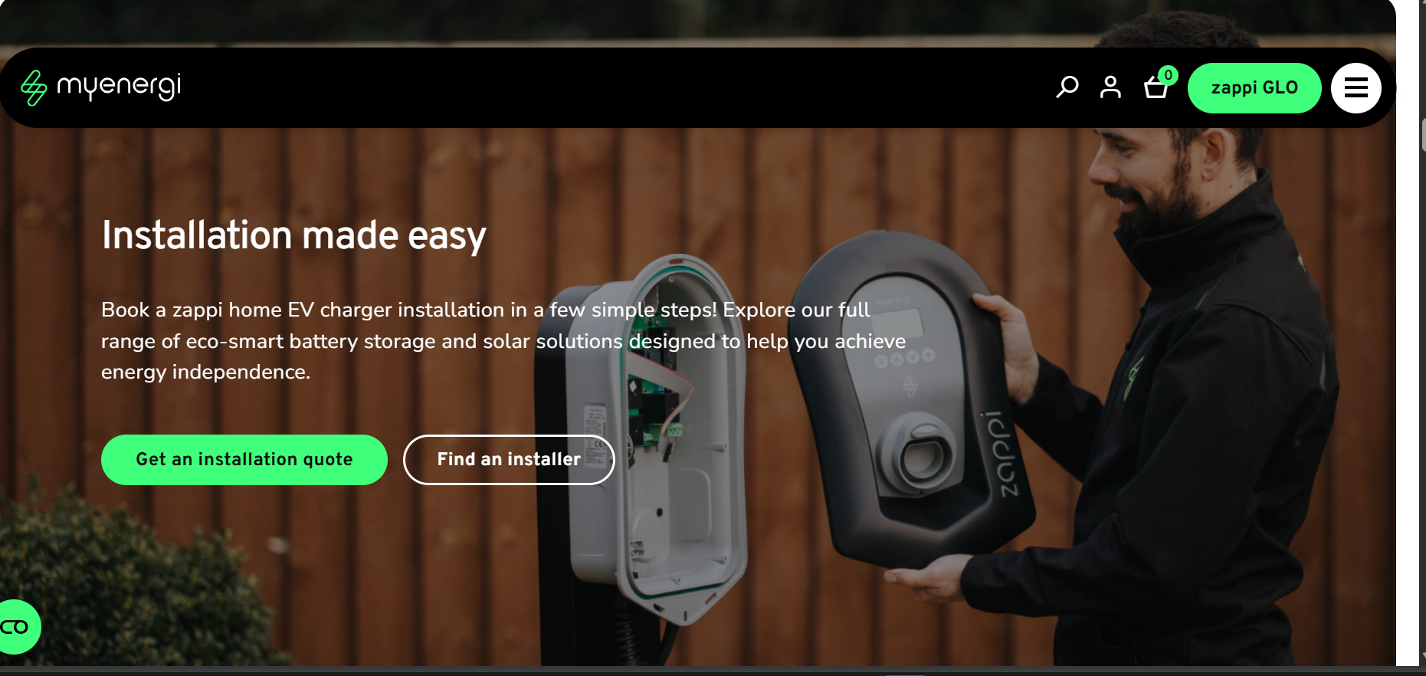

**Features we can adopt**

Since they offer EV charging and chargers on your homes, we can provide EV charger comparisons information like features, cost, sustainability, and installation requirements which is one of the requirements for the platform as it should provide its customers with information about green products currently on the market. Also, since they offer EV charger to your homes, they allow customer to book consultations and installations, so we can a add consultations and installations bookings flow that is streamlined for the customer as it's also one the important features requested by Rolsa Technologies.

Existing platforms tend to do one part of the journey well like monitoring or scheduling or carbon estimation, but Rolsa needs a unified solution that would educate users on green products and carbon reduction, supporting a secure account so customers can manage their consultation, installation and personal data, providing carbon footprint calculation and tracking, strong accessibility features with an inclusive design and supporting Rolsa’s internal operations by having an admin dashboard to view bookings, consultation pipeline and customer history.

New and evolving technologies can improve how customers learn about green energy, track their energy usage, and interact with Rolsa’s services. However, emerging tech can also introduce risks such as privacy issues, inaccurate data, accessibility barriers, or increased costs. The proposed solution will use emerging technologies where they provide clear value while applying safeguards to ensure data protection, fairness, and reliability.  
  
 ⸻  
  
**1) Internet of Things (IoT)**  
  
**What it is:**  
 IoT refers to physical devices (e.g., smart meters, solar inverters, EV chargers, smart thermostats) that connect to the internet to share real-time data.  
  
**How Rolsa could incorporate IoT:**  
 • Allow customers to link devices such as:  
 • solar inverter monitoring (generation data)  
 • smart meter readings (home consumption)  
 • EV charger usage (charging sessions)  
 • smart thermostat data (heating patterns)  
 • Show a dashboard that tracks:  
 • daily/weekly energy usage  
 • solar generation vs consumption  
 • estimated CO₂ savings  
 • Trigger alerts:  
 • unusually high usage  
 • reduced solar generation (possible fault)  
 • maintenance reminders for servicing  
  
**Benefits:**  
 • **More accurate tracking** than manual input (supports “calculate and track energy usage” feature).  
 • **Better customer decisions** (users can see what actions reduce their footprint).  
 • **Operational efficiency** (fault alerts can reduce callouts and support quicker repairs).  
 • Creates ongoing engagement after installation (customers keep using the platform).  
  
**Drawbacks / limitations:**  
 • **Compatibility issues:** customers may have different brands/models of devices; integration may not be universal.  
 • **Reliability risk:** devices can disconnect; data can be delayed or incomplete.  
 • **Security risk:** IoT devices can be attacked if poorly secured, creating a wider attack surface.  
 • **Cost + complexity:** building integrations takes development time and may require APIs or third-party platforms.  
  
**Ethical considerations (Band 3 depth):**  
 • **Privacy:** energy usage patterns can reveal personal routines (when people are home/asleep), so the platform must treat this as sensitive data.  
 • **Informed consent:** users should understand what is being collected and why, not hidden behind vague consent.  
 • **Digital exclusion:** users without smart devices should not be “punished” by having a worse experience.  
  
**Mitigations:**  
 • Make IoT linking **optional**, with a fully usable manual-entry mode.  
 • Use **secure authentication** for device linking (OAuth/API tokens where supported).  
 • Apply **data minimisation** (only store what’s needed) and give users controls to delete/export data (GDPR).  
 • Use encryption **in transit** (HTTPS/TLS) and **at rest** where practical, plus access control and logging.  
  
 ⸻  
  
**2) Cloud Computing**  
  
**What it is:**  
 Cloud computing provides hosted infrastructure (servers, databases, storage, analytics) accessed via the internet rather than relying on local hardware.  
  
**How Rolsa could incorporate cloud computing:**  
 • Host the platform on a cloud service for reliability and scale.  
 • Use cloud storage for:  
 • consultation documents (photos of roof/driveway/meter)  
 • invoices, installation plans, user manuals  
 • Use cloud monitoring/logging to measure uptime and performance (supports KPIs).  
  
**Benefits:**  
 • **Scalability:** handles traffic spikes (e.g., marketing campaigns) without slowing down.  
 • **Reliability:** easier to build backups, redundancy and disaster recovery.  
 • **Security tooling:** many cloud services provide managed security updates, monitoring, and encryption options.  
 • **Lower maintenance burden** compared to running on local machines.  
  
**Drawbacks / limitations:**  
 • **Ongoing cost model:** monthly costs can increase as usage grows.  
 • **Vendor lock-in risk:** moving between cloud providers can be difficult.  
 • **Internet dependency:** users and staff need stable internet access.  
  
**Ethical considerations:**  
 • **Data sovereignty and transparency:** users should know where data is stored and who processes it.  
 • **Responsible data retention:** keeping data “forever” is not ethical or compliant—there should be retention rules.  
  
**Mitigations:**  
 • Choose a provider with UK/EU region storage options and a clear compliance posture.  
 • Implement retention policies (e.g., delete old documents after X months unless legally required).  
 • Use role-based access controls so only authorised staff can access customer data.  
 • Build exportable data formats (helps portability + reduces lock-in).

**3) Augmented Reality (AR)**  
  
**What it is:**  
 AR overlays digital information onto the real world through a phone camera (e.g., visualising where an EV charger could be installed).  
  
**How Rolsa could incorporate AR (future enhancement):**  
 • Customers scan:  
 • their driveway/garage to preview EV charger placement  
 • their roof to understand solar panel placement ranges (high-level guide)  
 • Provide guidance overlays:  
 • required clearance space  
 • cable routing considerations  
 • “pre-install checklist” visual prompts  
  
**Benefits:**  
 • **Improves customer understanding** (reduces confusion and increases confidence).  
 • **Reduces wasted visits** by helping customers capture better pre-consultation info.  
 • Helps customers self-educate (aligns with “provide information about green energy products”).  
  
**Drawbacks / limitations:**  
 • **Accuracy limitations:** AR estimates are not final engineering measurements.  
 • **Device limitations:** not all phones support advanced AR smoothly.  
 • Can create false confidence if not clearly labelled as an estimate.  
  
**Ethical considerations:**  
 • **Honesty + transparency:** AR visuals must be clearly described as “guidance,” not a guarantee.  
 • **Accessibility:** AR features must not be required to access core services.  
  
**Mitigations:**  
 • Label AR as an “approximate visual guide” and provide standard alternatives (photos + manual form).  
 • Provide disclaimers and explain that a professional survey is required for final placement.  
  
 ⸻  
  
**4) Virtual Reality (VR)**  
  
**What it is:**  
 VR provides a fully immersive digital environment using a headset or 360° experiences (sometimes via a phone).  
  
**How Rolsa could incorporate VR (future enhancement):**  
 • VR showroom / virtual walkthrough:  
 • “how solar works,” “how EV charging works,” “smart home energy management”  
 • Training/education:  
 • basic safety info for homeowners  
 • how to read energy dashboards and reduce usage  
  
**Benefits:**  
 • Makes complex energy concepts easier to understand.  
 • Engaging educational tool for users who learn visually.  
 • Can reduce support queries by improving user understanding.  
  
**Drawbacks / limitations:**  
 • **Low adoption:** many users don’t own VR headsets.  
 • **Cost + time:** higher development effort compared to web content.  
 • Potential discomfort for users (motion sickness), and not accessible for all users.  
  
**Ethical considerations:**  
 • **Inclusion:** relying on VR could exclude users; it should never be essential.  
 • **Accessibility + wellbeing:** VR content must be optional and designed responsibly.  
  
**Mitigations:**  
 • Keep VR as “could-have / future feature” and provide non-VR equivalents (videos, articles, infographics).  
 • Ensure all learning content is available in accessible formats.  
  
 ⸻  
  
**Summary: Recommended approach for Rolsa**  
  
 For the initial version, the most valuable emerging technologies are **IoT** (energy tracking) and **cloud computing** (reliability, scalability, secure storage). **AR/VR** provide additional educational value but should be considered optional enhancements due to cost, device limitations, and accessibility concerns. All emerging tech features will follow privacy-by-design principles and ensure users can still complete core tasks (information access, footprint calculation, scheduling) without requiring advanced hardware.